# CNCCookbook 2015 CAM Market Share and Usage Report

# Survey Audience

CNCCookbook surveys its readers annually about the CAD and CAM preferences. We receive over 3 million visits a year to www.cnccookbook.com. Our audience is about 70% professionals and 30% hobbyist/makers. Geographically, our readership is as follows:

* Americas: 54.14%
* Europe: 23.85%
* Asia: 15.88%
* Rest of World: 6.13%

This report was compiled from hundreds of responses to our CAM Survey that was done in December, 2015.

# Market Share

This portion of our report concerns which CAM packages users reported as having in “production.”

## High-End CAM

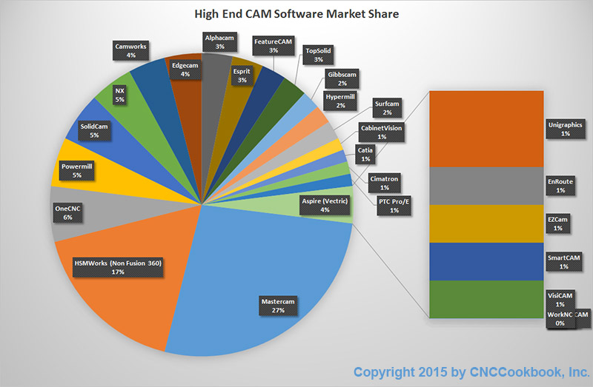

High-End CAM Software Market Share

The High End was the largest part of our survey and accounted for 47% of adoptions.

For our 2014 Survey, we remarked that the High-End CAM Software Market was crowded, fragmented, and somewhat confusing. There had been predictions of consolidation, but consolidation was not apparent in the data.

That has changed for our 2015 survey. There are still a great many players, but the Top 5 account for 5% of the market while in 2014 the Top 5 were 51%. The market is indeed gradually consolidating.

Here are the highlights of 2015 relative to the 2014 results:

* Mastercam remains the #1 player and even gained share—moving from 22% to 27%
* NX fell from #2 to #6 and is no longer in the Top 5.
* HSMWorks has made stunning gains—moving from #5 and 5% share to #2 and 17% share. Note that this is not the inexpensive Fusion 360 version. These are the full-featured versions that integrate with Solidworks and Inventor.
* OneCNC is hanging in at the same #3 position and even picked up some share, moving from 6% to 8%.
* Powermill and Solidcam are tied for the #4 and #5 places, but Solidcam has lost a little overall share while Powermill is coming on pretty strongly. Apparently the merger with Autodesk has been a good idea for the product.
* Below the Top 5, Edgecam, Alphacam, Esprit, TopSolid, and Hypermill all made good gains in market share. Notable share losers were GibbsCAM, SurfCAM, Catia, and Pro/E.

To understand the market share gains and losses better, you’ll want to drill down on some of the other survey analysis such as Share of Mind, Top Features, Top Frustrations, Conversions Rates and Product Strengths and Weaknesses.

## Tier-Priced CAM

The Tier-Priced category consists of products that are sold in modular fashion so you can build a CAM package at virtually any price point depending on how much functionality you need. As such they straddle multiple markets from low-end to high-end.

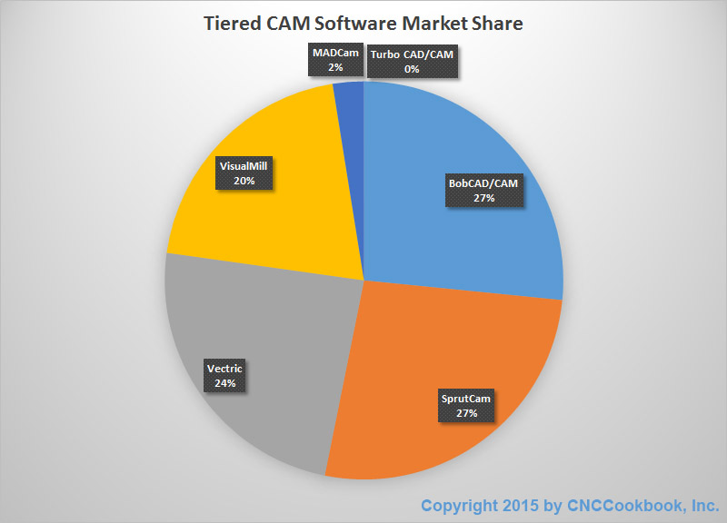

Tier-Priced CAM Software Market Share

When we did our 2014 survey, the Tier-Priced category was the second most popular segment, after the High-End. This year, its share places it in third place, and we think that is largely due to the incredible success of Fusion 360 at the Low End. 26% of our respondents were using Tier-Priced CAM packages.

There was quite a lot of upheaval in market shares among the Tier-Priced packages too:

* BobCAD/CAM moved up from #3 (18% share) to #1 place with 27% share.
* SprutCAM fell from #1 to #2 place going from 38% share to 27%.
* Vectric moved from #4 (17% share) to #3 with 24% share.
* Mecsoft’s family of products fell from #2 place (22%) to #4 place 20%. That’s not that big a share change for them.

In 2014 the Top 3 players in this segment had 78% of the segment. For 2015, the Top 3 also have 78%. The forces at work here are not consolidation but changing positions based on overall momentum. Like the High-End, more insights are possible by looking at some of the other reports.

## Low Cost CAM

These are the packages that Hobbyists and “Prosumers” (low-end business + high-end hobbyist) thrive on because their price points are relatively low. This was our second largest category having received 32% of the responses.

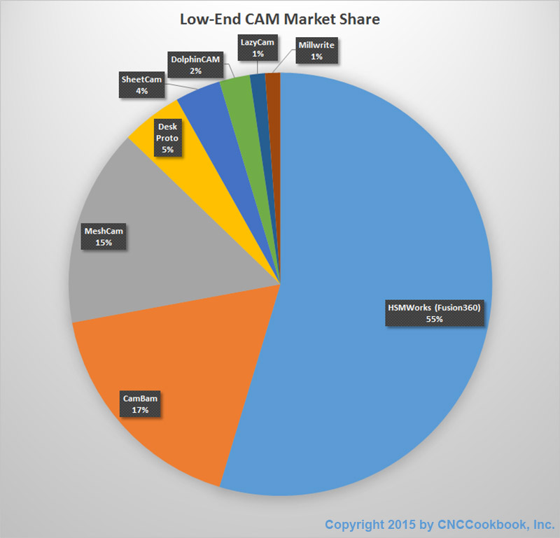

Low-End CAM Market Share

This is the market where Autodesk’s Cloud Strategy and Fusion 360 product have really taken over. The Top 3 players in 2014 had 61% market share while Fusion 360 is closing in on that all by itself. Every single player we tracked in this market lost some share to Fusion 360, it was only a matter of how much. CAMBAM stayed pretty flat while MeshCAM went from 23% to 15% share. The rest all did much worse.

The combination of nice parametric CAD, the very nice HSMWorks CAM, and all at a very affordable price is tough to beat. The low-end market is basically being offered a lot of the power that had been reserved for the High End and Tiered Segments at a very affordable price.

# Customer Satisfaction

Customer Satisfaction can be elusive to track down, but we all want the product whose customers love it the most. For this report, we measured Customer Satisfaction as a score in two ways. First, we asked respondents to rank their packages on a 1 to 3 scale where 1 = Not very good, 2 = OK, 3 = It rocks! Second, we asked whether the customer was actively searching for a new package to adopt. A mathematical formula related the percentage of each kind of answer to a Customer Satisfaction Score.

## High-End Top 5

1. Alphacam
2. Edgecam
3. Gibbscam
4. Featurecam
5. Solidcam

## Tiered Top 5

1. Vectric
2. Bob CAD/CAM
3. Sprutcam
4. VisualMill
5. MADCam

## Low-End Top 5

1. DolphinCAM
2. HSMWorks (Fusion 360)
3. MeshCam
4. CamBam
5. Desk Proto

For more detail on Customer Satisfaction, watch for our follow-up blog posts and updates to this document. Over time, we will provide scores for every single package in the survey.

# Share of Mind (Trials)

To learn more about Share of Mind, we asked respondents to tell us which packages they had tried. Just because a package had not been deployed to production does not mean respondents were unfamiliar with the package. In fact, in our Premium Report we related these two together to understand what the conversion rates are—how many have to try a package to achieve an adoption.

The percentage of respondents who trialed each segment was virtually identical to the percentage who adopted. This suggests the segmentation used was robust and actually reflects the type of user doing the evaluation.

## High-End CAM Mind Share

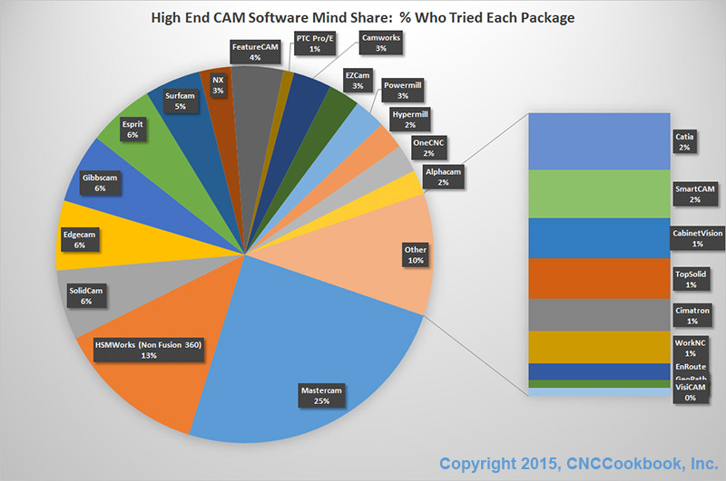

High-End CAM Software Mind Share: % Who Tried Each Package

Mind share is all about the marketing efforts of the companies involved as well as the ability and desire of their customer base to spread the news by word of mouth. When the mind share of a product is larger than its market share, this may reflect increased marketing spending or a particularly loyal customer base. For insights into customer loyalty, drill down on our Customer Satisfaction report.

Meanwhile, a couple observations about Market vs Mind Share.

On average, customers looked at 2.4 packages before adopting one. This was almost identical to the Tiered segment while the Low-End evaluates even fewer packages (2.2 before adoption), presumably because the cost of failure is less.

The Top 5 companies whose adoption is higher than their mind share (i.e. people exposed are very likely to adopt) at the High-End are:

1. HSMWorks (Non Fusion 360)
2. OneCNC
3. Powermill
4. Mastercam
5. Alphacam

## Tiered Segment Mind Share

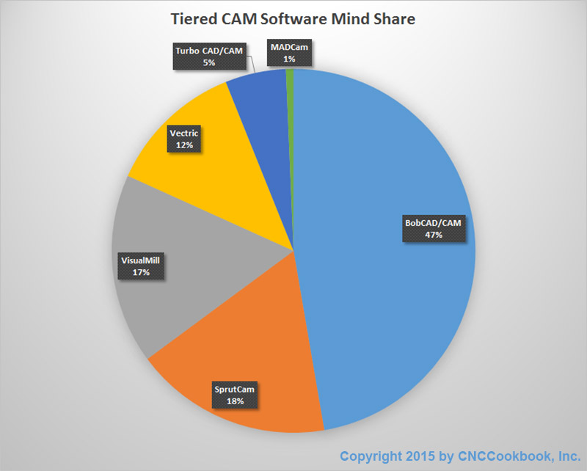

Tiered Segment Mind-Share

Companies where adoption leads mind share (Fewer Trials lead to more adoption):

1. Vectric
2. SprutCam
3. MADCAM
4. Visual Mill

## Low-End Segment Mind Share

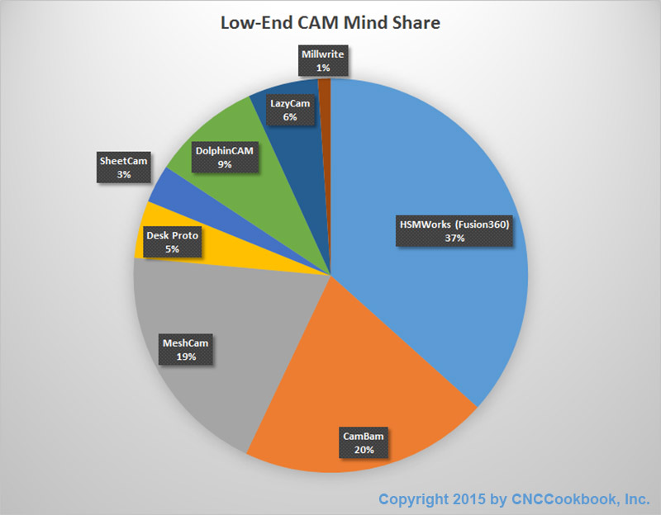

Low-End Segment Mind Share

Companies where adoption leads mind share (Fewer Trials lead to more adoption):

1. HSMWorks
2. Millwrite
3. Sheetcam

# Follow-On Reports

For those who require more information from the survey, we will be updating this document with additional analysis. When all the analysis is available, it will be an ideal resource for market participants (i.e. CAM Software Developers and Dealers) or groups charged with making large investments in CAM Software for their organizations.

Report updates are available from CNCCookbook: <http://www.cnccookbook.com/CC2015CAMPDFDownload.html>

We’re planning to add the following additional information:

# Customer Satisfaction Drilldown

Analysis and discussion of customer satisfaction scores and score components for every CAM package.

# Product Strengths & Weaknesses

Top Features and Frustrations are discussed and a Feature Grid is provided that shows which CAM packages were noted by respondents for each feature.

# Conversion Rates and Sales Strategy

A complete analysis is provided for each package that discusses which other packages are being trialed against it by respondents and what the likelihood of adoption is against various competitors.